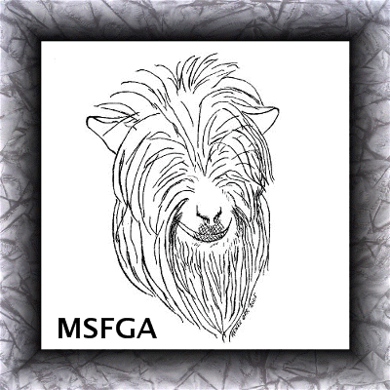
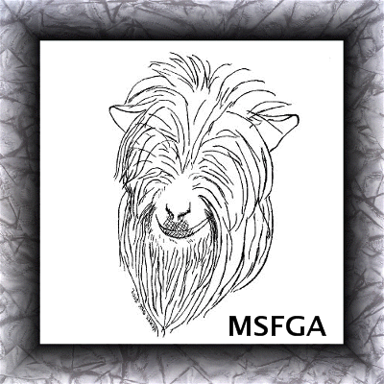
Miniature Silky Fainting Goat Association
22105 Countryside Lane, Lignum, VA 22726-2025
540-423-9193 fax: 540-423-9196

Instructions for Registering an Animal

Every animal to be registered must have a name. Names must be limited to 30 letters and spaces, including herd name. Names that exceed 30 spaces will be rejected or modified by the registrar. The animal’s name should begin with the breeder’s prefix or name. If you are not the breeder of the animal, you will not be able to use your herd prefix in naming the animal. The animal’s name must be unique within the registration data base. Please print names clearly.
The breeder of an animal is the owner of the dam at time of conception. If the breeder is not the owner of the buck, the buck information must be filled out and signed by the owner of the buck on the application for registration.
Sire owners; please indicate if the breeding was done naturally or if the doe was artificially inseminated.
Unworthy or unsound animals or those not having the standard breed characteristics should not be presented for registry. Such animals will not be registered in the herd books of the MSFGA, when the facts are known. False and unworthy registrations will be cancelled without a refund.
Under color description, give specific colors and markings. Disbudded or otherwise removing the horns does not make the animal horn-less.
All animals presented for registration must have tattoo numbers assigned to it prior to registration. The right ear should have the farm letter tattoo and the left ear should have the letter representing the year the kid was born followed by a number. If using microchips or scrapie tags for identification, then a microchip number or scrapie tag should be assigned to the animal and implanted before registration.
***Please Remember - Attach one good, crisp picture of the animal being registered to go on the Registration Certificate. You may send in a picture of any size, it will be scanned into our computer and cropped at 150 dpi to 2 inches X 2 inches for the registration certificate.

*If you are a resident of CANADA, please send MoneyGram or Western Union in US dollars made payable to Renee Orr. Checks written off of US banks will also be accepted.

Your Herd Name Must Be Registered with The MSFGA In Order For You To Register Goats With Us.

Miniature Silky Fainting Goat Association
22105 Countryside Lane, Lignum, VA 22726-2025
540-423-9193 fax: 540-423-9196
Application for Registration
This application is to be used for kids born out of MSFGA registered parents.
Fees: Up to 1 year $15 Over 1 year to 2 years $20 Over 2 years $25

Name of Animal:
PLEASE PRINT - Names limited to 30 letters & spaces, including herd prefix. Names exceeding allowed spaces won’t be registered.

Date of birth: (mm/dd/yyyy): |  |  |  |  |  |  |  | Sex: (Male, Female or Wether):
No. of Males in birth: |  |  |  | No. of Females in birth: |  |  |  |  |  | Does this goat faint? Yes |  |  |  |  | No
Color description:
Please choose one: |  | Horned |  |  |  |  | Polled |  |  |  |  | Disbudded
Please enclose one good, crisp, color picture of the whole animal being registered.
*All Goats Must a Have a Scrapie Tag, Tattoo or Micro-Chip. Goats can not be registered without this info.
Tattoo identification: |  | right: |  |  |  |  | left: |  | tail:
Microchip brand & number:
Location of microchip: |  |  |  |  |  |  |  | Scrapie tag#:
Breeder: |  |  |  |  |  | Farm:
(Owner of dam at time of conception, person’s name not farm name)

Sire: |  |  |  |  |  |  |  |  |  |  |  |  |  |  |  |  |  | MSFGA Number:
Owner: |  |  |  |  |  |  |  |  |  |  |  |  |  | Farm:
*Signature of Sire Owner:
This breeding was done: |  |  |  |  |  |  | Naturally: |  |  |  |  |  |  |  |  |  | By Artificial Insemination:
 |  |  |  |  |  |  |  | (Please check one of the above as to how the breeding was done)
Dam: |  |  |  |  |  |  |  |  |  |  |  |  |  |  |  |  |  | MSFGA Number:
Owner: |  |  |  |  |  |  |  |  |  |  |  |  |  |  | Farm:
*Born the property of (signature):
Name:
*[ ] Check here if this is a new address for you
Full Address:
Phone: |  |  |  |  |  |  |  |  |  | Email:
Transfer of Ownership - $5 whether the goat is registered or not.
*Seller’s Signature: |  |  |  |  |  |  |  |  |  |  |  |  |  |  |  |  |  |  |  | Date of Transfer:
Sold to: |  |  |  |  |  |  |  |  |  |  |  |  |  |  |  | Farm:
Address:
Phone: |  |  |  |  |  |  |  |  |  | Email:
*Signature of new owner:
Your Herd Name must be registered with the MSFGA before you can register goats in your name.
Make check payable to MSFGA and send to the address above.
Please don’t use this Ownership Transfer Form for goats that are registered with MSFGA, the Ownership Transfer Form is on the back of the MSFGA registration certificate.

