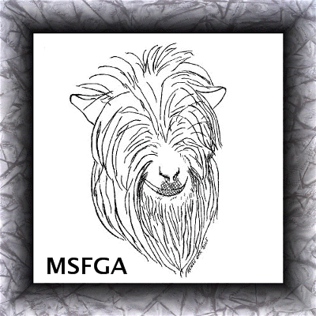
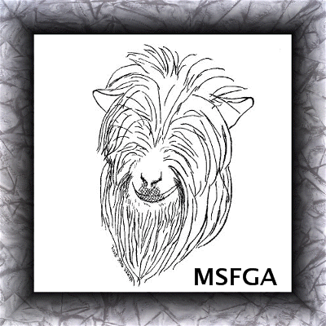
Miniature Silky Fainting Goat Association
22105 Countryside Lane, Lignum, VA 22726-2025
540-423-9193 fax: 540-423-9196

Instructions for Registering a Herd Name

A herd, farm or business name must be registered with MSFGA in order for you to register goats with us. When the owner of this herd, farm or business name is registering animals that they are the breeder of, they shall use this “exact” prefix in the names of those animals. A registered herd name is reserved as a prefix only, not as a suffix. Choose Tattoo Letters, this is a required field. Tattoo registration is free of charge with the registration of a herd name. The MSFGA will not register tattoos without registration of a herd name.

To register a herd name, fill out and send in a Herd Name Application along with the appropriate fee, giving first, second and third choices of name, incase the first or second choice is already taken. Once the application is processed the applicant will receive a herd name certificate. That herd, farm or business name will then be permanently owned by the applicant.

Farm names, herd names or company names cannot be accepted as signatures for registration or transfers, unless the owner or other authorized agent also signs the application.

The fee for registering a herd name is $50.00. *If you are a resident of CANADA, please send either a check issued off of a US bank, send money by MoneyGram or Western Union. MSFGA also accepts PayPal, please send in USD to msfgaregistry@gmail.com

Miniature Silky Fainting Goat Association
22105 Countryside Lane, Lignum, VA 22726-2025
540-423-9193 fax: 540-423-9196

Application for Herd Name Registration

Herd Name 1st Choice:
Herd Name 2nd Choice:
Herd Name 3rd Choice:
Tattoo Letters:
*You Must Choose Tattoo Letters. For example: If you Herd, Farm or Business Name is “My Goat Farm”, you might choose the tattoo letters “MGF” to reflect the name of your farm and to identifying your goats. (If tattoo letters are already taken, then a number will be assigned at the end of the letters.)

Owner Name:
Street Address:
City, State & Zip:
Phone: |  |  |  |  |  | Fax:
Email Address:
Website Address:

Signature: __________________________________________________________

Herd registration fee is $50.00. Please make check payable to MSFGA and mail to the address above. All residents of CANADA please send payment to Renee Orr by MoneyGram or Western Union. Checks or money orders from US banks are also accepted. MSFGA also now accepts PayPal, please send in USD to msfgaregistry@gmail.com

